Chapter 4. Logistic regression

4.1 The logistic regression model
For a binary response variable $Y$, we model the success probability $P(Y=1)$. we denote this by π(x) to emphasize that the value of $P(Y =1)$ depends on the value $x$ of that variable.
4.1.1 The logistic regression model
The logistic regression model is of the form
$$logit\left[π\left(x\right)\right]=\log\left[\frac{π\left(x\right)}{1-π\left(x\right)}\right]=α+βx.$$
Logistic regression has a corresponding formula for $π(x)$
$$π\left(x\right)=\frac{e^{α+βx}}{1+e^{α+βx}} .$$
4.1.2 Odds ratio and linear approximation interpretations
From the logistic regression equation, we obtain
$$\frac{π\left(x\right)}{1-π\left(x\right)}=\exp{(α+βx)}=e^{α}{\left(e^{β}\right)}^{x}.$$
Therefore, the odds multiply by $e^{β}$ for every 1-unit increase in $x$. That is, the odds at level $x+1$ equal the odds at $x$ multiplied by $e^{β}$.
A simpler interpretation refers to the probability $π(x)$ itself. Since the model for $π(x)$ is curved rather than a straight line, the rate of change in $π(x)$ per 1-unit increase in $x$ depends on the value of $x$. A straight-line drawn tangent to the curve at a particular $x$ value, describes the rate of change at that point. For logistic regression parameter $β$, that line has slope equal to $βπ(x)[1 - π(x)]$. For instance, the line tangent to the curve at $x$ for which $π(x)=0.50$ has slope $β(0.50)(0.50) = 0.25β$. The steepest slope occurs when $π(x)=0.50$. That $x$ value relates to the logistic regression parameters by $x=-α/β$. This $x$ value is sometimes called the median effective level. It represents the point at which each outcome has a 50% chance.
4.1.3 Example: whether a female horseshoe crab has satellites
For probability $π(x)$ that a female horseshoe crab of width $x$ has a satellite, the logistic regression model fit is
$$logit\left[\hat{π}\left(x\right)\right]=-12.351+0.497x.$$
Thus, the estimated probability of a satellite
$$\hat{π}\left(x\right)=\frac{\exp{(-12.351+0.497x)}}{1+\exp{(-12.351+0.497x)}} .$$
Since $\hat{β}>0$, the estimated probability is higher at larger width values ($x)$. Since $\hat{β}=0.497$, the estimated odds of a satellite multiply by $\exp\left(\hat{β}\right)=\exp{(0.497)}=1.64$ for each 1-cm increase in width; that is, there is a 64% increase.
The median effective level, at which $\hat{π}\left(x\right)=0.5$, is $x=-\hat{α}/\hat{β} =12.351/0.497=24.8$.
At the sample mean width of 26.3 cm, $\hat{π}\left(x\right)=0.674$. The incremental rate of change in the fitted probability at that point is $\hat{β}\hat{π}\left(x\right)\left[1 - \hat{π}\left(x\right)\right]=0.497\left(0.674\right)\left(0.326\right)=0.11$. For female crabs near the mean width, the estimated probability of having at least one satellite increases at the rate of 0.11 per 1-cm increase in width.
4.2 Statistical inference for logistic regression
4.2.1 Confidence intervals for effects
A Wald confidence interval for the effect in the logistic regression model, $logit\left[π\left(x\right)\right]=α+βx$, is $\hat{β}±z_{α/2}(SE)$. Exponentiating the endpoints yields an interval for $e^{β}$, the multiplicative effect on the odds of a 1-unit increase in $x$.
For logistic regression modeling of the horseshoe crab data, Since $\hat{β}=0.497$ with $SE=0.102$, the 95% Wald confidence interval for $β$ is
$$0.497±1.96\left(0.102\right)=\left(0.298, 0.697\right).$$
The profile likelihood confidence interval is $\left(0.308, 0.709\right)$, for which the interval for the effect on the odds is $\left(e^{0.308}, e^{0.709}\right)=\left(1.36, 2.03\right)$. We infer that a 1-cm increase in width has at least a 36% increase and at most a doubling in the odds that a female crab has a satellite.
At $\hat{π}\left(x\right)=0.5$, the estimated rate of change is $0.25\hat{β}=0.124$. A 95% confidence interval for $0.25β$ equals 0.25 times the endpoints of the interval for β. For the profile likelihood interval, that is $\left[0.25\left(0.308\right), 0.25\left(0.709\right)\right]=(0.077, 0.177)$. Therefore, for values of $x$ near the width value at which $\hat{π}(x)=0.50$, we infer that the rate of increase in the probability of a satellite per 1-cm increase in width falls between about 0.08 and 0.18.

4.2.2 Significance Testing
Suppose the hypothesis $H_{0}:β=0$. For large samples, the Wald test statistic $z=\hat{β}/SE$ has a $N(0,1)$ distribution when $β=0$. The likelihood-ratio test is more powerful and more reliable than the Wald test, especially when $n$ is small or when the effect $β$ is strong. Let $L_{0}$ denote the maximum of the log-likelihood function when $β=0$, which is the null model, and let $L_{1}$ denote the maximum log-likelihood for unrestricted $β$. The test statistic $2\left(L_{1}-L_{0}\right)=Deviance_{0}-Deviance_{1}$ has a large-sample chi-squared null distribution with $df =1$.
For the example in 4.1.3, the Wald statistic is $z=\hat{β}/SE=0.497/0.102=4.89$, which shows strong evidence of a positive effect of width on the presence of satellites. The likelihood-ratio test statistic is $225.76 -194.45 = 31.31$, with $df=172-171=1$. This also provides extremely strong evidence of a width effect. We can obtain this test in R directly using the “Anova” function in the “car” package.

4.2.3 Fitted values and confidence intervals for probabilities
It can also construct a confidence interval for $P(Y =1)$ at each $x$ value. For female crabs of width $x=26.5$, which is near the mean width, the estimated probability of a satellite is $\hat{P}(Y =1)=0.695$ and a 95% confidence interval for $P(Y =1)$ is $(0.61, 0.77)$. (by R)

4.2.4 Why Use a Model to Estimate Probabilities?
When the logistic regression model holds, the model-based estimator is much better than the sample proportion. It uses all the data rather than only the data at the particular $x$ value. The result is a more precise estimate. Also, the model smooths the sample data, somewhat dampening the observed variability.

4.3 Logistic regression with categorical predictors
4.3.1 Indicator variables represent categories of predictors
Suppose that a binary response has two binary explanatory variables, which we denote by $x$ and $z$. We denote the two categories of $x$ and $z$ by the values 0 and 1. Then $x$ and $z$ are called indicator variables (or dummy variables), because each indicates the category of an explanatory variable. For the logistic model
$$logit\left[P\left(Y=1\right)\right]=α+β_{1}x+β_{2}z$$
with 0/1 coding, Table 4.1 shows the logit values at the four combinations of values of the two explanatory variables.

Table 4.1 Logits implied by indicator variables in logistic model
with two binary factors, $logit\left[P\left(Y=1\right)\right]=α+β_{1}x+β_{2}z$.
$$x$$ | $$z$$ | Logit
0 | 0 | $$α$$
1 | 0 | $$α+β_{1}$$
0 | 1 | $$α+β_{2}$$
1 | 1 | $$α+β_{1}+β_{2}$$
At a fixed category $z$, the effect on the logit of changing from $x=0$ to $x=1$ is $β_{1}$. For each category $z$, the odds of success at $x=1$ equal $\exp{(β)}$ times the odds of success at $x=0$.

4.3.2 Example: Survey about marijuana use
Table 4.2 is from a survey that asked students in their final year of a high school near Dayton, Ohio, whether they had ever used marijuana. The explanatory variables are gender and race.
Table 4.2 Use of marijuana by gender and race.
Race$(z)$ | Gender$(x)$ | Marijuana Use
 |  | Yes | No
White$(z=1)$ | Female$(x=0)$ | 420 | 620
 | Male$(x=1)$ | 483 | 579
Other$(z=0)$ | Female$(x=0)$ | 25 | 55
 | Male$(x=1)$ | 32 | 62

The ML estimated effects are ${\hat{β}}_{1}=0.203$ for gender and ${\hat{β}}_{1}=0.444$ for race. The estimated conditional odds ratio between marijuana use and gender equals $\exp{(0.203)}=1.22$. For each race, the estimated odds that a male $(x=1)$ had used marijuana were 1.22 times the estimated odds that a female had used marijuana. For each gender, the estimated odds that a person of white race $(z=1)$ had used marijuana were $\exp{(0.444)}=1.56$ times the estimated odds that a person of other races had used marijuana.
The comparison of the null and residual deviances, $12.75-0.06=12.69$, is the likelihood-ratio statistic with $df=3- 1=2$ for testing $H0: β_{1}=β_{2}=0$. This has chi-squared $P-value=0.002$. We can conclude that at least one of the explanatory variables has an effect. The hypothesis that gender has no effect on marijuana use, adjusting for race, is $H0: β_{1}=0$. The likelihood-ratio statistic comparing the model with the simpler one having no gender effect equals the difference in residual deviances for the two models. This is 5.67, with $df=1$, showing evidence of association $(P=0.017)$. The Wald statistic $z={\hat{β}}_{1}/SE=0.203/0.085=2.38$ provides similar results. The effect of race is also significant.

4.4 Multiple logistic regression
For p explanatory variables, the model for the log odds is
$$logit\left[P\left(Y=1\right)\right]=α+β_{1}x_{1}+β_{2}x_{2}+…+β_{p}x_{p}.$$
The parameter $β_{j}$ refers to the effect of $x_{j}$ on the log odds that $Y=1$, adjusting for the other $x$’s. For example, $\exp{(β_{1})}$ is the multiplicative effect on the odds of a 1-unit increase in $x_{1}$, at a fixed value for $x_{2},... ,x_{p}$.

4.4.1 Example: Horseshoe Crabs with Color and Width Predictors
We use (1) shell width (quantitative) and (2) color (categorical) as explanatory variables. Color has categories (1 = medium light, 2 = medium, 3 = medium dark, 4 = dark). Color is a surrogate for age, with older crabs tending to have a darker shell color. It is an ordinal variable, but we first treat it as a nominal-scale factor.
The model is
$$logit\left[P\left(Y=1\right)\right]=α+β_{1}x+β_{2}c_{2}+β_{3}c_{3}+β_{4}c_{4} ,$$
where $x$ denotes the shell width and
$c_{2}=1$ for color $=$ medium, 0 otherwise,
$c_{3}=1$ for color $=$ medium dark, 0 otherwise,
$c_{4}=1$ for color $=$ dark, 0 otherwise.
The fitted model is as below:
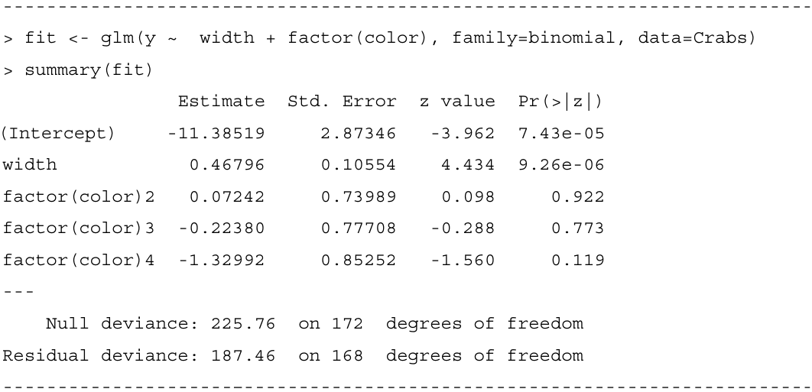
For medium-light colored crabs (category 1), $c_{2}=c_{3}=c_{4}=0$, and the prediction equation is
$$logit\left[\hat{P}\left(Y=1\right)\right]=-11.385+0.468x.$$
For dark crabs (category 4), $c_{2}=c_{3}=0$ and $c_{4}=1$, so the prediction equation is as below:
$$logit\left[\hat{P}\left(Y=1\right)\right]=\left(-11.385-1.330\right)+0.468x=-12.715+0.468x.$$
The exponentiated difference between two color parameter estimates is an odds ratio comparing those colors. For example, the difference in color parameter estimates between medium-light crabs and dark crabs equals 1.330. Therefore, at any fixed value of width, the estimated odds that a medium-light crab has a satellite are $\exp{(1.330)}=3.8$ times the estimated odds for a dark crab. Using the probabilities just calculated at width 26.3, the odds equal $0.399/0.601=0.66$ for a dark crab and $0.715/0.285=2.51$ for a medium-light crab, for which $2.51/0.66=3.8$.

4.4.2 Model comparison to check whether a term is needed.
To test whether color contributes significantly, we test $H_{0}:β_{2}=β_{3}=β_{4}=0$. This hypothesis states that, adjusting for width, the presence of at least one satellite is independent of color. The test statistic is
$$2\left(L_{1}-L_{0}\right)=194.45-187.46=6.99.$$
Under $H_{0}$, this test statistic has an approximate chi-squared distribution with $df=3$. The $P-value$ of 0.07 provides slight evidence of a color effect. Since the analysis in 4.4.1 noted that estimated probabilities are quite different for dark-colored crabs, it seems safest to leave color in the model.

4.4.3 Example: Treating color as quantitative or binary.
Color has a natural ordering of categories, from medium light to dark. A simpler model treats color in a quantitative manner. It is advantageous to treat ordinal explanatory variables in a quantitative manner, when such models fit well. The model is simpler and easier to interpret, and tests of the effect of the variable are generally more powerful when it has a single parameter rather than several parameters.
To illustrate, we use scores $c=(1,2,3,4)$ for the color categories and fit the model
$$logit\left[P\left(Y=1\right)\right]=α+β_{1}x+β_{2}c.$$
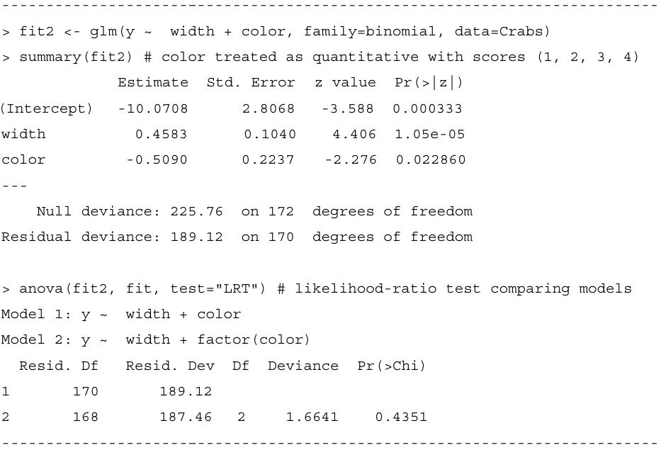
At a given width, for every one-category increase in color darkness, the estimated odds of a satellite multiply by $\exp{(-0.509)}=0.60$. For example, the estimated odds of a satellite for dark-colored crabs are 60% of those for medium-dark crabs. Since $\exp\left[3\left(-0.509\right)\right]=0.22$, the estimated odds of a satellite for dark-colored crabs are 22% of those for medium-light crabs.
The difference between the deviances equals $189.12-187.46=1.66$, with $df=2(P=0.44)$. It tests that the color parameters in model, when plotted against the color scores, follow a linear trend. The simpler model seems to be adequate.
The estimates of the color parameters in the model that treats color as a nominal scale factor are $(0, 0.07, -0.22, -1.33)$. The 0 value for the first category reflects the lack of an indicator variable for that category. Although these values do not depart significantly from a linear trend, the first three are similar compared to the last one. This suggests that another potential color scoring is $(0,0,0,1)$; that is, $c=1$ for dark-colored crabs, and $c=0$ otherwise.
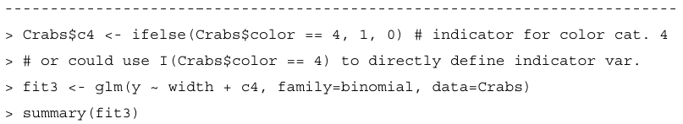
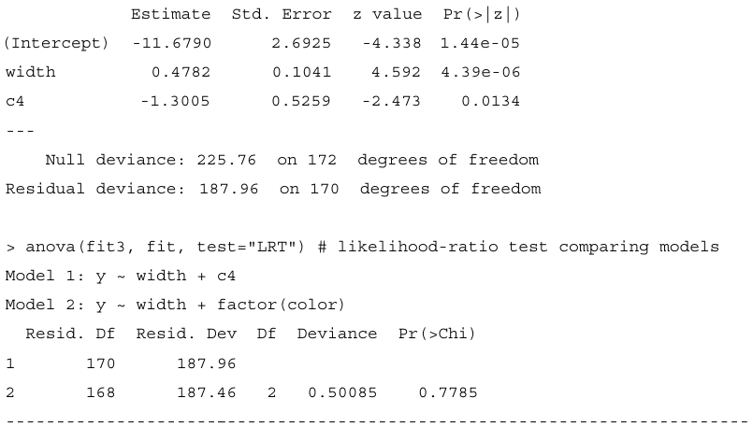
At a given width, the estimated odds that a dark crab has a satellite are $\exp\left(-1.3005\right)=0.27$ times the estimated odds for a lighter-colored crab. The likelihood-ratio statistic comparing this model with binary scoring to model (4.3) with color factor suggests that this simpler model also seems adequate.
In summary, the model with color factor, the model with quantitative color scores (1, 2,3,4), and the model with binary color scores (0,0,0,1) all suggest that dark crabs are the least likely to have satellites. When the sample size is not very large, typically several models can fit adequately.
4.4.4 Allowing Interaction between explanatory variables.
The models fitted so far assume a lack of interaction between width and color. Let us check now whether this is sensible. We can allow interaction by adding cross-products of terms for width and color. Each color then has a different-shaped curve relating width to the probability of a satellite, so a comparison of two colors varies according to the value of width.
To illustrate, we consider the model just fitted that has an indicator variable for dark-colored crabs. We next fit the model with an interaction term:
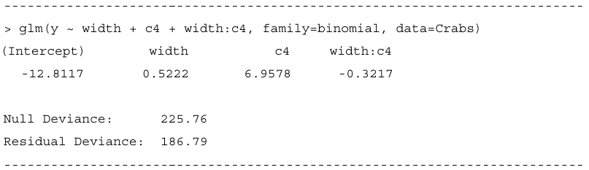
The prediction equation is
$$logit\left[\hat{P}\left(Y=1\right)\right]=-12.812+0.522x+6.958c_{4}-0.322\left(x∙c_{4}\right).$$
For dark-colored crabs $(c_{4}=1)$,
$$logit\left[\hat{P}\left(Y=1\right)\right]=-5.854+0.200x.$$
For lighter-colored crabs $\left(c_{4}=0\right)$,
$$logit\left[\hat{P}\left(Y=1\right)\right]=-12.812+0.522x.$$

